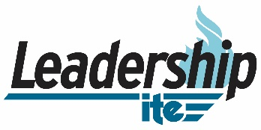
LeadershipITE 2023 Program Information Webinar
AGENDA

Wednesday, Aug 17, 2022

11:30 am to 1:00 pm
- Introduction
  - Guest Speaker - Ms. Shelley Row, PE, CSP

- LeadeshipITE 2023 Comprehensive Program Overview

- TexITE Board and Section Members
    - Greater Dallas Section
    - Greater Fort Worth Section
    - Capital Area Section
    - Brazos Valley Section
    - South Texas Section
    - Lone Star Section
    - Houston Section


- LeadershipITE Program Application Process and Deadlines
  - Application Packet
https://www.ite.org/professional-and-career-development/leadershipite/
    - Completed application form;
    - Responses to short essay questions;
    - Nomination letter from current or past ITE District or Section officer;
    - Support letter from current employer; and
    - Support letter from non-employer.
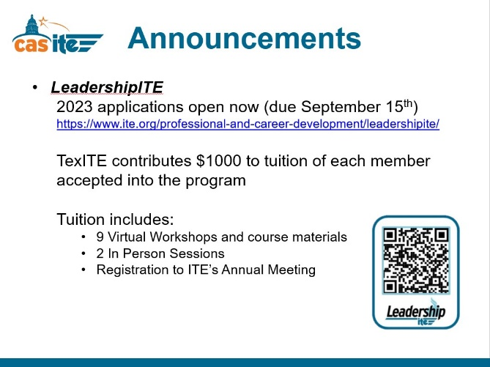
  - Deadlines
    - LeadershipITE Application deadline is September 15, 2022
    - LeadershipITE funding deadline is November 15, 2022

- TexITE District and Section Funding Support

- LeadeshipITE Alumni Experiences

- Q&A

