|  |  |
| --- | --- |
| Institute of Transportation Engineers (ITE)__________ DistrictStrategic Plan Developmentdate | Place District  Logo Here |

# INTRODUCTION

This document is intended to be utilized by ITE Districts to kick-off their strategic planning process. It provides a sample agenda for a half-day planning session along with an outline of activities that can be utilized to guide the initial process for plan development. This planning session should ideally be conducted in person and should include the District Board, Committee Chairs, and other senior leaders from within your District and ITE International. An ideal time to conduct this session is in conjunction with your Annual Meeting because most of the key individuals will already be traveling to the same location.

# SAMPLE AGENDA

|  |  |
| --- | --- |
| Welcome Remarks & Icebreaker | 1:00 |
| Plan Timeline and Session Goals & Objectives | 1:20 |
| District Mission & Vision Activity, Discussion | 1:30 |
| Break | 2:00 |
| Advanced Reading Discussion | 2:10 |
| Strategic Plan Outline Review | 2:30 |
| Break | 3:00 |
| District Themes Discussion | 3:10 |
| Themes Breakout Groups, Discussion | 3:30 |
| Break | 4:00 |
| Theme & Goals Champions | 4:10 |
| Timeline Review, Action Items, & Single-Voice Check-Out | 4:50 |
| Adjourn & Happy Hour | 5:00 |

# Planning Session Outline

## Welcome Remarks & Icebreaker

Session leader welcomes the team and gives an overview of the purpose of the working group and the planning session, then facilitates the icebreaker/introduction activity.

### Icebreaker Activity

Please give your name, role in ITE, and tell us what you’re most excited about in developing the District Strategic Plan.

## Plan Timeline and Session Goals & Objectives

Session leader will present the anticipated timeline along with the session’s goals and objectives. An example six-month timeline is provided below, although a twelve-month timeline may be more realistic for most Districts.

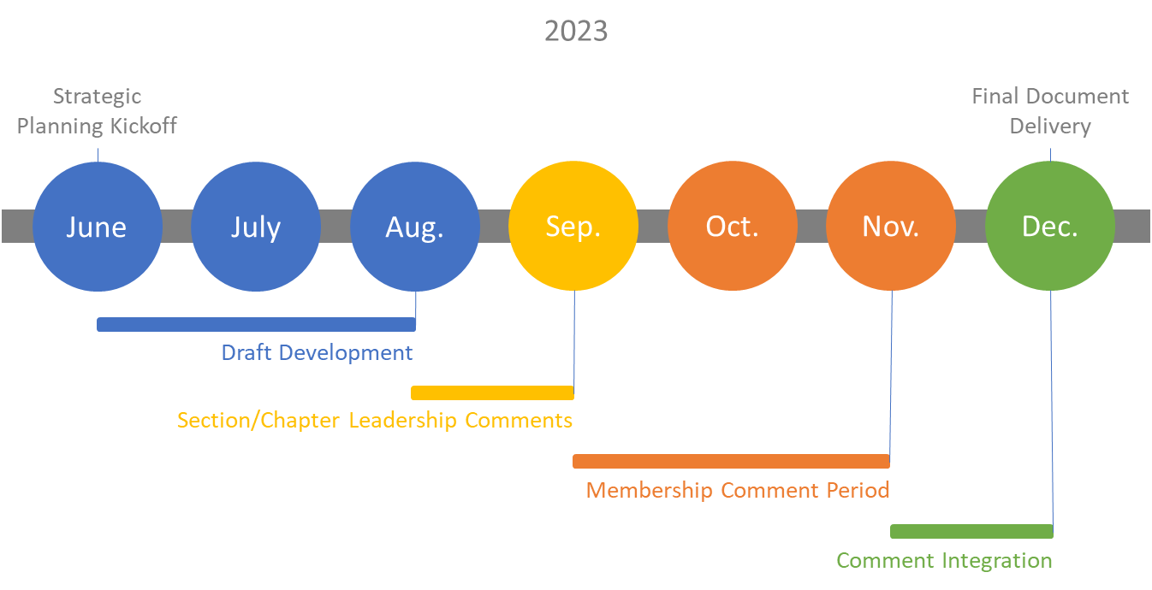

### Session Goals

* Prepare draft Mission & Vision statements for the District
  + Possibly present the Mission & Vision statements in the President’s address at the annual meeting, or in the next district newsletter
* Confirm the strategic plan outline – team buy-in
* Generate 2-4 Themes on which the District will focus in the three-year Strategic Plan
* Assign Champions for each theme who will develop district-level goals

## District Mission & Vision Activity, Discussion

In this session, present the mission and vision statements generated by other districts and the International organization, or initiate an activity to produce mission/vision statements for your district. Example draft language is provided in the tables below.

#### Mission Statements

|  |  |  |
| --- | --- | --- |
| To provide the global community of transportation professionals with the knowledge, practices, skills and connections to serve the needs of their communities and help shape the future of the profession and transportation in the societal context. | International | ITE Logo |
| To provide the Canadian Transportation Community opportunities to learn, connect, contribute and grow to best meet the needs for safe and healthy mobility in Canada. | Canada | ITE Canada |
| To join transportation professionals operating in the Mountain West with opportunities to learn, grow, and connect as we deliver safe, equitable, and robust transportation solutions to the communities we serve. | Mountain District |  |

#### Vision Statements

|  |  |  |
| --- | --- | --- |
| To be the transportation organization of choice | International | ITE Logo |
| Our members are making their communities a better place – safer, more efficient and livable – through meaningful careers in transportation | Western |  |
| To be the organization of choice for all transportation industry professionals in the Mountain West | Mountain District |  |

## Advanced Reading Discussion

In advance of the work session, distribute the ITE International, and example district strategic plans to the attendees with the request that they review them and come prepared to discuss the following prompt questions:

1. What did you respond positively to in your review of the sample strategic plans?
2. Were there any parts that you disliked or would like to see us avoid in our plan?
3. What was missing in the sample plans that you’d like to see included in our work?
4. Do you think the membership of these districts would see their own priorities reflected in these plans?

## Strategic Plan Outline Review

* Organizational Mission/Vision
* Purpose Statement
* District Themes/Principles
  + Goals/Strategies for each theme

## District Themes Discussion

In this session, discuss the themes/priorities included in the sample plans. Prompting questions might include:

1. Which themes are applicable to our role at the district-level?
2. How may these themes either enhance or constrain the ways we serve our members?

|  |  |  |
| --- | --- | --- |
| * Membership * Technical Knowledge * Institutional Sustainability | International | ITE Logo |
| * Membership Growth * Membership Value Retention * Value of our products and services * Organizational Strength | Canada | ITE Canada |
| * Culture * Membership * Organizational Strength | Mountain District |  |

## Themes Breakout Groups, Discussion

Break the group into pairs/triads to generate a diverse set of lists for possible district-level themes. This activity can be followed by a group discussion to identify overlaps in the respective lists of themes and determine if there are 2-4 clear directions, or if more discussion is required.

## Theme & Goals Champions

In this discussion, finalize your district themes and identify champions or small groups to take on the task of developing goals for each. Propose deadlines to the group for returning their goals for integration into the draft plan. Build in time for executive review and comment integration before distributing the plan to the Board and Committee Chairs for review and comment.

## Timeline Review, Action Items, & Single-Voice Check-Out

In this wrap-up time, session leader can revisit the plan timeline with the group. Delineate action-items and their champions, and review in brief the progress we’ve made together in our first session.