SMART Grants Program FY24 NOFO Launch
Sample Social Posts
May 13 - July 12, 2024
Below are sample posts that interested stakeholders and SMART Grant Program awardees can use to share the SMART Grant FY24 Stage 1 NOFO launch with their networks and encourage eligible applicants to apply to the NOFO. The NOFO will be open for 60 days through 5:00PM ET July 12, 2024.
X (formerly Twitter) | LinkedIn
Post on day of NOFO launch
NOFO Launch  @USDOT launched the next SMART Grant Stage 1 NOFO today! Public agencies have until July 12, 2024 to apply with innovative tech demo projects for safer, more resilient communities. This will be the last Stage 1 NOFO for the SMART program.  https://tinyurl.com/cty2ztfr  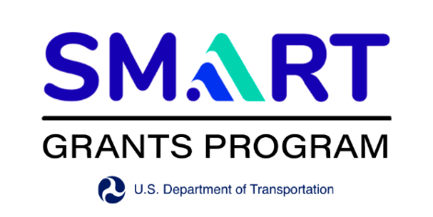 | NOFO Launch  The U.S. DOT launched the next SMART Grant Stage 1 NOFO today! Public agencies have until July 12, 2024 to apply with innovative tech demo projects for safer, more resilient communities and join the 93 SMART projects already in progress. This will be the last Stage 1 NOFO for the SMART program as currently appropriated.  There will be a ‘How to Apply’ webinar on May 28th, 2024. Sign up on the SMART Program website.  https://tinyurl.com/cty2ztfr
Post a few days before May 14th
Reminder to register for the ‘How to Apply’ Webinar  Interested in applying for SMART Stage 1? Sign up for the ‘How to Apply’ webinar on May 28th. Eligible agencies have until July 12th to apply.  https://tinyurl.com/cty2ztfr  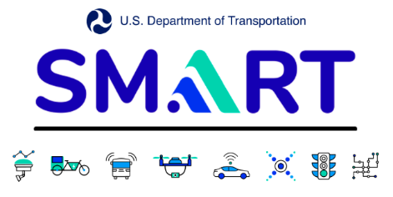 | Reminder to register for the ‘How to Apply’ Webinar  Interested in applying for SMART Stage 1? Remember to sign up for the ‘How to Apply’ webinar on May 28th. Eligible agencies have until July 12th to apply.  The recording and slides from the webinar will be posted to the SMART Grants website after the webinar. You can also find more information on how to apply, resources, and FAQs on the SMART website.  https://tinyurl.com/cty2ztfr
Post around June 15
Final reminder to apply  The deadline for the SMART Stage 1 Grants is coming up! Applications are due soon. This will be the last year for Stage 1 Grants, so all interested, eligible entities are encouraged to apply by July 12th.  https://tinyurl.com/cty2ztfr | Final reminder to apply  The deadline for the SMART Stage 1 Grants is coming up! Applications are due July 12th. This will be the last year for Stage 1 Grants, so all interested, eligible entities are encouraged to apply. The SMART Program Website has complete ‘how to apply’ information, frequently asked questions, illustrative use cases, and more.  https://tinyurl.com/cty2ztfr

Additional SMART Graphics for individual technology areas that can be used:

Sensors | 
System Integration | 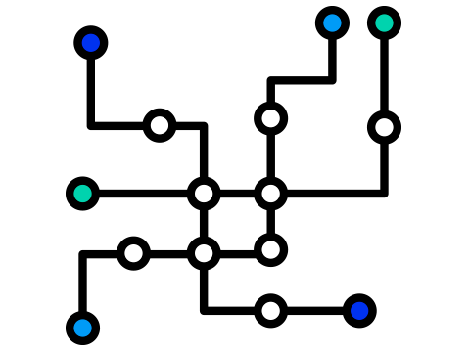
Commerce and Logistics | 
Coordinated Automation | 
Connected Vehicles | 
Smart Traffic Signals | 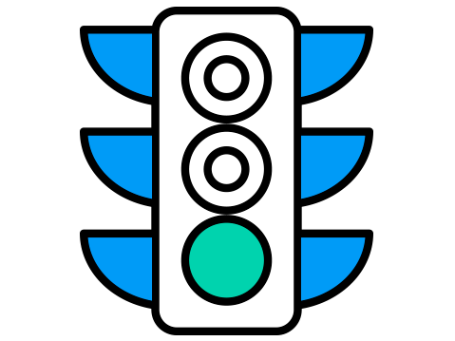
Smart Grid | 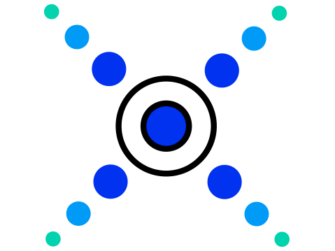
Innovative Aviation | 

